**Citizens With Disabilities - Ontario**

**19th Annual General Meeting**

**May 22, 2024**

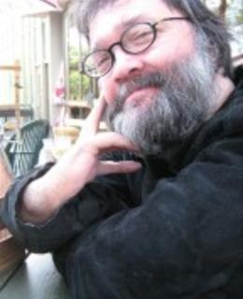

# The Environment and You:

# The missing and/or ignored voice

# Dr. Gregor Wolbring

# Guest Speaker

Disabled people/people with disabilities are impacted by many environmental issues in many ways. There is the issue of the changing climate with an increase in bad weather events such as heatwaves, flooding, fires, etc. As such how to prepare, prevent and deal with such events needs your voice as you are in very specific ways impacted by these bad weather events.

There are many activists that work on environmental topics, but they rarely involve disabled people/people with disabilities. Their understanding of how their activism affects disabled people/people with disabilities is low or ignores the negative effects of the activism.At the same time disabled people/people with disabilities face many barriers to being activists in general.

Environmental education teaches students on environmental issues but miss the lived reality of disabled people/people with disabilities and the influence such lived reality (e.g. many disabled people/people with disabilities live in poverty) has on how disabled people/people with disabilities experience the environmental changes.

Without you there can not be any environmental justice.

Bio on next page.

# **Bio**

Dr. Gregor Wolbring is a wheelchair user born without legs (thalidomider). He has been involved with the Council of Canadians with Disabilities since he moved to Canada in 1992. He was also involved in activism in the UK and Germany where he lived before 1992.

Dr. Wolbring received the Council of Canadians with Disability National Award in 1998. An academic working on many different disability issues, Dr. Wolbring received the EDI award at his university in 2022. Read much more about him at <https://wolbring.wordpress.com/about/>